**Power BI Assignment 5**

**1- Explain DAX.**

**Ans**- Data Analysis Expressions (DAX) is a programming language that is used throughout Microsoft Power BI for creating calculated columns, measures, and custom tables. It is a collection of functions, operators, and constants that can be used in a formula, or expression, to calculate and return one or more values.

DAX includes many functions that return a table rather than a value. The table is not displayed but is used to provide input to other functions. For example, you can retrieve a table and then count the distinct values in it or calculate dynamic sums across filtered tables or columns.

DAX Syntax-

A DAX formula always starts with an equal sign (=). After the equals sign, you can provide any expression that evaluates to a scalar, or an expression that can be converted to a scalar. These include the following: A scalar constant, or expression that uses a scalar operator (+, -, *,/,>=,...,&&, ...)

two types of DAX functions

Image result for Explain DAX in power BI

I can create two types of expressions or

1-calculations using DAX in Power BI

2-calculated columns and calculated measures.

Following is an example of DAX formula, which uses a function to calculate a column in a table.

DAX function can also include other functions, conditional statements, and value references.

DAX Functions-In Power BI, you can use different function types to analyse data, and create new columns and measures. It includes functions from different categories such as −

**Aggregate**

Text

Date

Logical

Counting

Information

**Aggregate Functions**

DAX has a few aggregate functions.

MIN

MAX

Average

SUM

SUMX

**Counting Functions**

Other counting functions in DAX include −

DISTINCTCOUNT

COUNT

COUNTA

COUNTROWS

COUNTBLANK

**Logical Functions**

Following are the collection of Logical functions −

AND

OR

NOT

IF

IFERROR

**TEXT Functions**

REPLACE

SEARCH

UPPER

FIXED

CONCATENATE

**DATE Functions**

DATE

HOUR

WEEKDAY

NOW

EOMONTH

**INFORMATION Functions**

ISBLANK

ISNUMBER

ISTEXT

ISNONTEXT

ISERROR

**DAX Calculation Types**

In Power BI, you can create two primary calculations using DAX −

Calculated columns.

Calculated measures.

**2- Explain datasets, reports, and dashboards and how they relate to each other?**

**Ans**- Dataset- A dataset is a collection of data that you import or connect to. Power BI lets you connect to and import all sorts of datasets and bring all of it together in one place. Datasets can also source data from dataflows. Datasets are associated with workspaces and a single dataset can be part of many workspaces.

Reports- A Power BI report is a multi-perspective view into a data model, with visualizations that represent different findings and insights from that data model. A report can have a single visualization or pages full of visualizations. Depending on your role, you may read and explore reports, or you may create them for others.

Dashboard- A Power BI dashboard is a single page, often called a canvas, that tells a story through visualizations. Because it's limited to one page, a well-designed dashboard contains only the highlights of that story. Readers can view related reports for the details. Dashboards are a feature of the Power BI service.

Dashboards and Reports are the two main components of the Power BI solution. There is a misconception about Report that it is a detailed tabular report, and about the dashboard is that it is an interactive visualisation with the chart.

There is a difference between them and understanding differences will help you leverage their power in the best way.

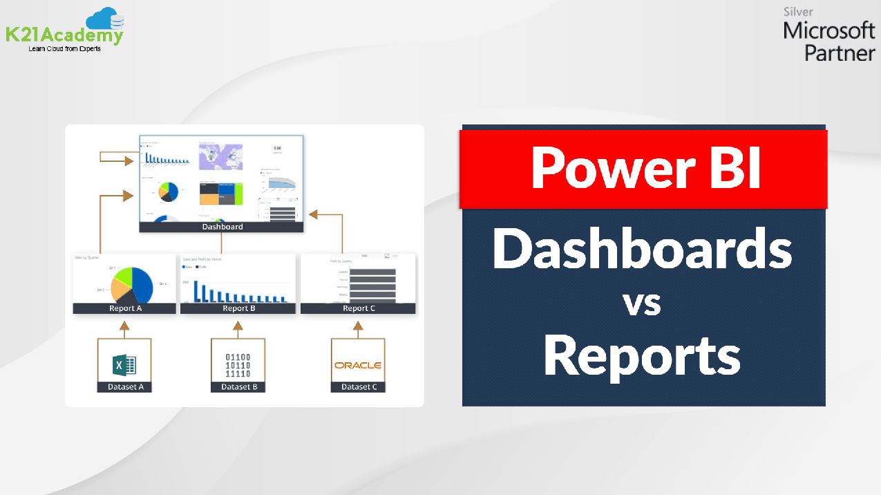

**3- How reports can be created in power BI, explain two ways with Navigation of each.**

**Ans**-There are several ways to create reports quickly in the Power BI service. Instead of downloading the Power BI Desktop app and importing the data, you can paste data straight into Power BI on the web, and Power BI automatically generates visuals for you.

**1- Create a report from an Excel file in the Power BI**

When I first load data in Power BI Desktop, I'll see the Report view with a blank canvas, with links to help us to add data to your report.

I can switch between Report, Data, and Model views by selecting the icons in the left-hand navigation pane:

Once I've added some data, I can add fields to a new visualization in the canvas,

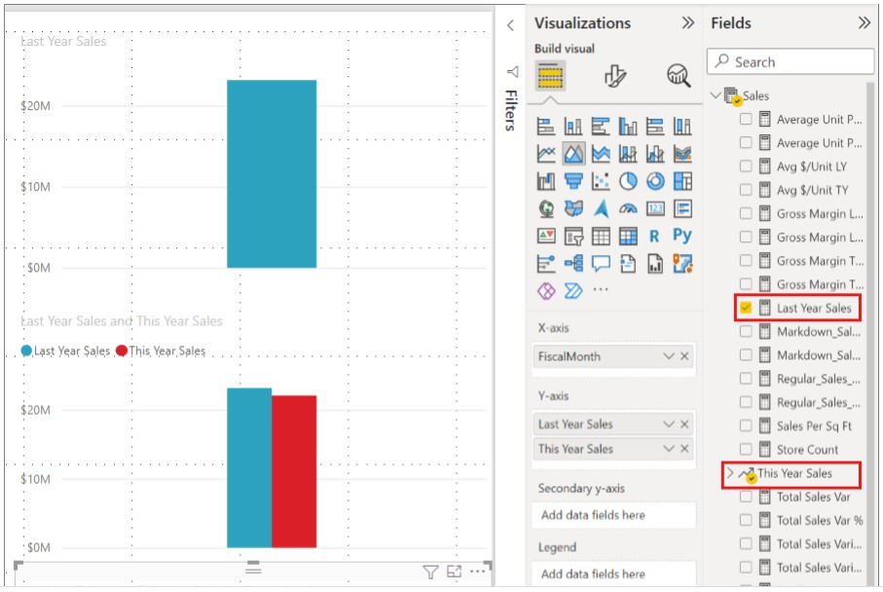

To change the type of visualization, we can select it on the canvas, then select a new type in Visualizations.

I can select report themes by going to the View ribbon. In the Themes section

**2- Create a report quickly from a Text/CSV file**

There's a new way to create reports quickly from data to start with, from Power BI Desktop select Get data > Text/CSV from the Home ribbon

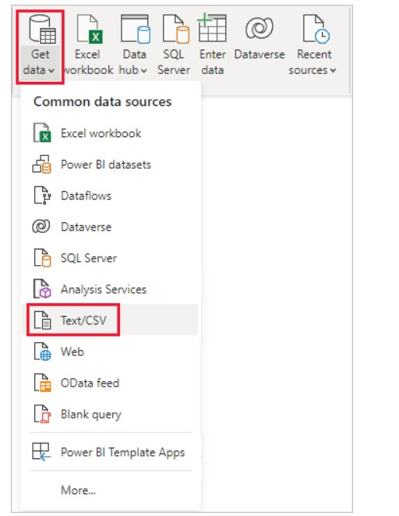

Select CSV file from the Open dialog that appears.

When we select Open, Power BI Desktop accesses the file and determines certain file attributes, such as the file origin, delimiter type, and how many rows should be used to detect the data types in the file.

These file attributes and options are shown in the dropdown selections at the top of the CSV import dialog window. You can change any of these detected settings manually, by choosing another option from any of the dropdown selectors.

When you're satisfied with the selections, you can select Load to import the file into Power BI Desktop, or you can select Transform Data to open Power Query Editor and further shape or transform the data before importing it.

Once we load the data into Power BI Desktop, you see the table and its columns, which are presented as Fields in Power BI Desktop, in the Fields pane, along the right of the Report view in Power BI Desktop.

The data from we CSV file is now in Power BI Desktop. I can use that data in Power BI Desktop to create visuals, reports, or interact.

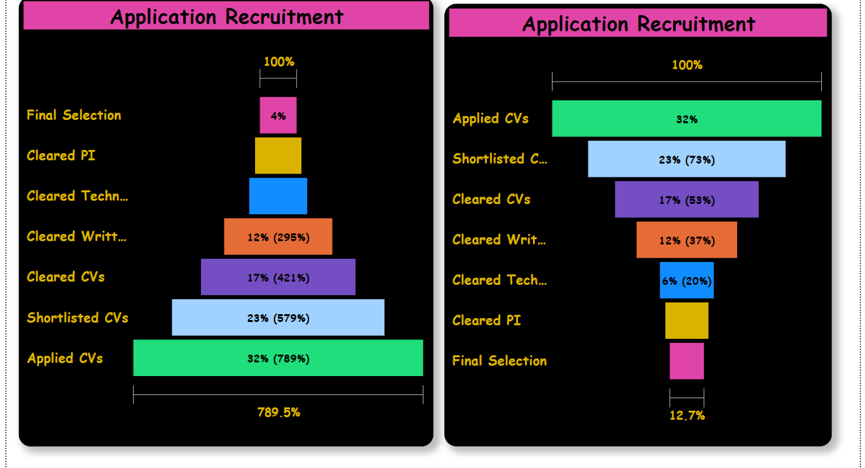

**4- How to connect to data in Power BI? How to use the content pack to connect to google analytics? Mention the steps.**

**Ans**- To connect to data, from the home ribbon select Get data. The Get Data window appears. You can choose from the many different data sources to which Power BI Desktop can connect.

connect to Google Analytics data using the Google Analytics connector. To connect, follow these steps:

In Power BI Desktop, select Get data from the home ribbon tab.

In the Get Data window, select Online Services from the categories in the left pane.

Select Google Analytics from the selections in the right pane.

At the bottom of the window, select connect.

we prompted with a dialog that explains that the connector is a Third-Party Service and warns about how features and availability may change over time, and other clarifications.

When we select Continue, we're prompted to sign in to Google Analytics.

When you enter your credentials, you're prompted that Power BI would like to have offline access. This is how you use Power BI Desktop to access your Google Analytics data.

Once we accept, Power BI Desktop shows that we’re currently signed in.

Select Connect, and Google Analytics data is connected to Power BI Desktop, and loads the data.

Data is connected now.

**5- How to import Local files in Power BI? Mention the Steps.**

**Ans**- In Power BI, click Get Data in the lower left screen. or click excel from get data.

Under Import or Connect to Data > Files, click Get.

Click Local File.

Choose which file to upload and click Open.

After that this page will come to connect data and loading.

Now power query opened and combined.

Here, you can see the two options ‘Combine & Transform’ and ‘Combine & Load’. In combine & transform, you can merge two or more tables and transfer through power query. In Combine & load, you can merge the table and load directly.

Load-This is used to load the folder directly.

Transform-This option is used to transform the data.

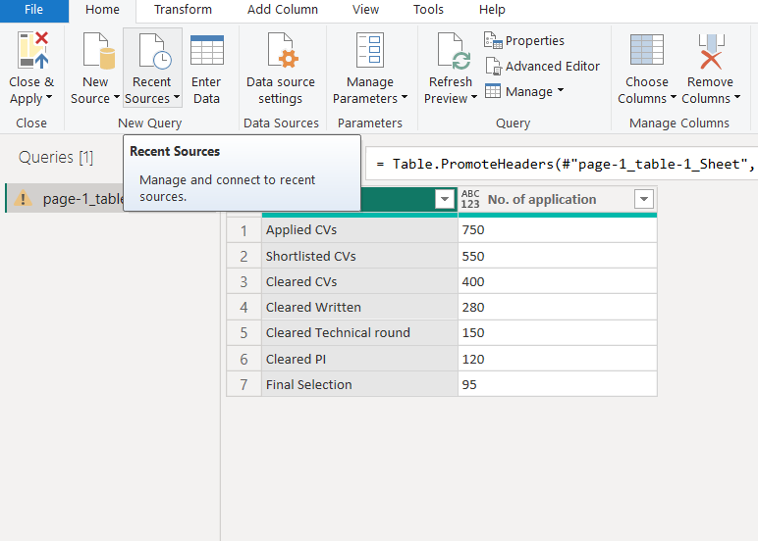

now we can see top right corner online retail will appear and we can view the records and use.

now to create a report. In the first report, I am showing the Online retail. Here I am selecting table visualization,

**6- In Power BI visualization, what are Reading View and Editing view?**

**Ans**- The Power BI service has two different modes for interacting with reports: Reading view for report business users and Editing view for report owners and creators. You need a Power BI Pro or Premium Per User (PPU) license to share reports and to edit reports created by others.

Reading view is your way to explore and interact with reports created by colleagues.

Even in Reading view, the content isn't static. You can dig in, looking for trends, insights, and other business intelligence. Slice and dice the content, and even ask it questions using your own words. Or, sit back and let your data discover interesting insights for you; send you alerts when data changes, and email reports to you on a schedule you set. All your data, any time, in the cloud or on-premises, from any device.